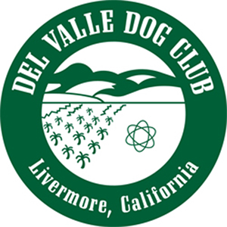DEL VALLE DOG CLUB OF LIVERMORE
Application for Membership

Name______________________________________________________________

Address ___________________________________________________________
City____________________________________ Zip Code _____________
Home phone (____)______-__________ Cell phone (____)______-__________
Email address ______________________________________________________
Occupation (past and/or present) ______________________________________
Primary breed(s), if any ______________________________________________
If not 18 years or older, are you applying for Junior Membership ____________

Activities you’re involved in:
Breeder_____ Conformation exhibitor____ Rally_____
Obedience____ Agility____ AKC judge_____ Junior handler____
Stewarding____
Have you ever been suspended by AKC? yes____ no____
If yes, please explain: _________________________________________________________________________________________________________________________________________________________________________________________________________________________________
Are you a member in other dog clubs? If yes, please list:
_______________________________________________________________________________________________________________________________________________________________________________________________________________________________________________________________________________________________________________________________________________________________________________________

Page 1 of 2

DEL VALLE DOG CLUB OF LIVERMORE
Application for Membership
Are you interested in helping out at the Del Valle Obedience Classes at The Barn in Livermore? yes____ no____ maybe____

Are you interested in helping out at our annual shows in October?
yes____ no_____ If yes, does any specific area interest you?

*As a courtesy to exhibitors, it is the policy that no member of the Del Valle Dog Club of Livermore or members of their household will exhibit or handle a dog owned or co-owned by them at DVDC AKC shows.

Signed ______________________________________ Date ______________

- - - - - - - - - - - - - - - - - - - - - - - - - - - - - - - - - - - - - - - - - - - - - - - - - - - - - - - - - -
Please obtain the signatures of two members in good standing to propose and endorse your application:
Proposed by:
Signed ______________________________________ Date_______________

Endorsed by:
Signed ______________________________________ Date _______________

Please make your check for dues payable to the Del Valle Dog Club and submit to the club secretary, Pat Rutherford, 122 Goodwin St., Hayward, CA 94544
(510)207-7629 pat.rutherford@comcast.net
Individual - $25.00 Family - $45.00 Junior - $4.00
Your application will be read at two successive meetings while you are in attendance, and voted upon at the third meeting you attend.

1st reading ____________ 2nd reading _____________
Voted into membership _________________________

Revised 9/30/20 Page 2 of 2

